

**LOAN TITLE POLICY BINDER ON INTERIM CONSTRUCTION LOAN (T-13)**

**ISSUED BY**

**WFG NATIONAL TITLE INSURANCE COMPANY**

**BINDER NO. T13-<Policy_Number>**

The Company commits to issue a Loan Policy of Insurance to the Proposed Insured as of the Date and Time and in the Amount shown on SCHEDULE A hereof and insuring the Lien described in SCHEDULE A hereof, subject to the exceptions shown in SCHEDULE B hereof and pursuant to the requirements herein made and in the form then promulgated by the Commissioner of Insurance of the State of Texas.

Upon receipt of evidence showing compliance with and satisfaction of the requirements set forth under SCHEDULE C of this Binder, or in the event that said requirements are not complied with that proper exception is taken, and upon payment of the applicable premium therefor, the Company will issue its Loan Policy in the face amount and as of the date and time set forth and covering the lien described in SCHEDULE A hereof.

Nothing herein contained shall be construed as insurance against the effect of zoning ordinances, if any, or the consequences of the exercise and enforcement or attempted enforcement of governmental "Police Power" over the property. No inspection of the premises has been made by this company or its Agent, and this Binder is subject to any state of facts that a physical inspection would show.

This Binder is delivered and accepted upon the understanding that you have no personal knowledge or intimation of any defect, objection, lien or encumbrance affecting said premises other than those shown under SCHEDULE B hereof, and your failure to disclose any such personal information shall render this Binder and any policy issued based thereon, null and void as to such defects, objections, liens and encumbrances.

This Binder shall not be binding until it shall have been countersigned by an Officer or Agent of the Company.

This Binder is preliminary to the issuance of the Loan Policy referred to above, and in no event shall it be effective after one year from the date set forth in SCHEDULE A hereof unless extended in writing for a term or terms prescribed by the regulations of the Texas Department of Insurance and unless the premium of such extension is paid.

The Company's liability hereunder shall be determined by Exclusions from Coverage, and the terms, conditions and stipulations of the Loan Policy referred to above; provided that the Company shall have no liability unless and until payment is made of the applicable premium for the above referred to Loan Policy.

EXECUTED as of the date and hour shown on Schedule "A".

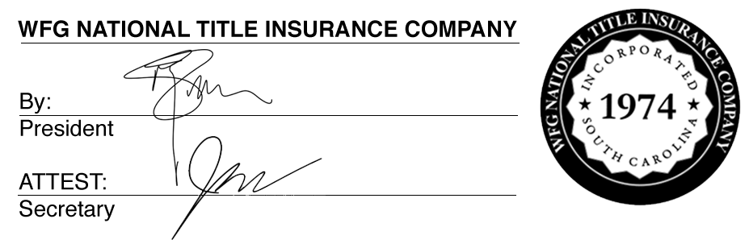

By_________________________________________

Authorized Signature

**Texas Form T-13: Loan Policy Title Binder on Interim Construction Loan (2/1/10)**

**WFG National Form No. 3154648**

Page **1** of **2**

**IMPORTANT NOTICE**

To obtain information or make a complaint:

You may call WFG National Title Insurance Company's toll-free telephone number for information or to make a complaint at:

**1-800-257-2842**

You may also write to WFG National Title Insurance Company at:

**12909 SW 68th Parkway, Suite 350**

**Portland, Oregon 97223**

You may contact the Texas Department of Insurance to obtain information on companies, coverages, rights, or complaints at:

**1-800-252-3439**

You may write the Texas Department of Insurance:

P.O. Box 149104

Austin, TX 78714-9104

Fax: (512) 490-1007

Web: [www.tdi.texas.gov](http://www.tdi.texas.gov)

E-mail: [ConsumerProtection@tdi.texas.gov](mailto:ConsumerProtection@tdi.texas.gov)

**PREMIUM OR CLAIM DISPUTES:**

Should you have a dispute concerning your premium or about a claim, you should contact the company first. If the dispute is not resolved, you may contact the Texas Department of Insurance.

**ATTACH THIS NOTICE TO YOUR POLICY:**

This notice is for information only and does not become a part or condition of the attached document.

**AVISO IMPORTANTE**

Para obtener informaciόn o para presentar una queja:

Usted puede llamar al número de teléfono gratuito de WFG National Title Insurance Company’s para obtener informaciόn o para presentar una queja al:

**1-800-257-2842**

Usted también puede escribir a WFG National Title Insurance Company:

**12909 SW 68th Parkway, Suite 350**

**Portland, Oregon 97223**

Usted puede comunicarse con el Departamento de Seguros de Texas para obtener informaciόn sobre compañias, coberturas, derechos, o quejas al:

**1-800-252-3439**

Usted puede escribir al Departamento de Seguros de Texas a:

P.O. Box 149104

Austin, TX 78714-9104

Fax: (512) 490-1007

Sitio web: [www.tdi.texas.gov](http://www.tdi.texas.gov)

E-mail: [ConsumerProtection@tdi.texas.gov](mailto:ConsumerProtection@tdi.texas.gov)

**DISPUTAS POR PRIMAS DE SEGUROS O RECLAMACIONES:**

Si tiene una disputa relacionada con su prima de seguro o con una reclamaciόn, usted debe comunicarse con el la compañia primero. Si la disputa no es resuelta, puede comunicarse con el Departamento de Seguros de Texas.

**ADJUNTE ESTE AVISO A SU PÓLIZA:**

Este aviso es solamente para propόsitos informativos y no se convierte en parte o en condiciόn del documento adjunto.